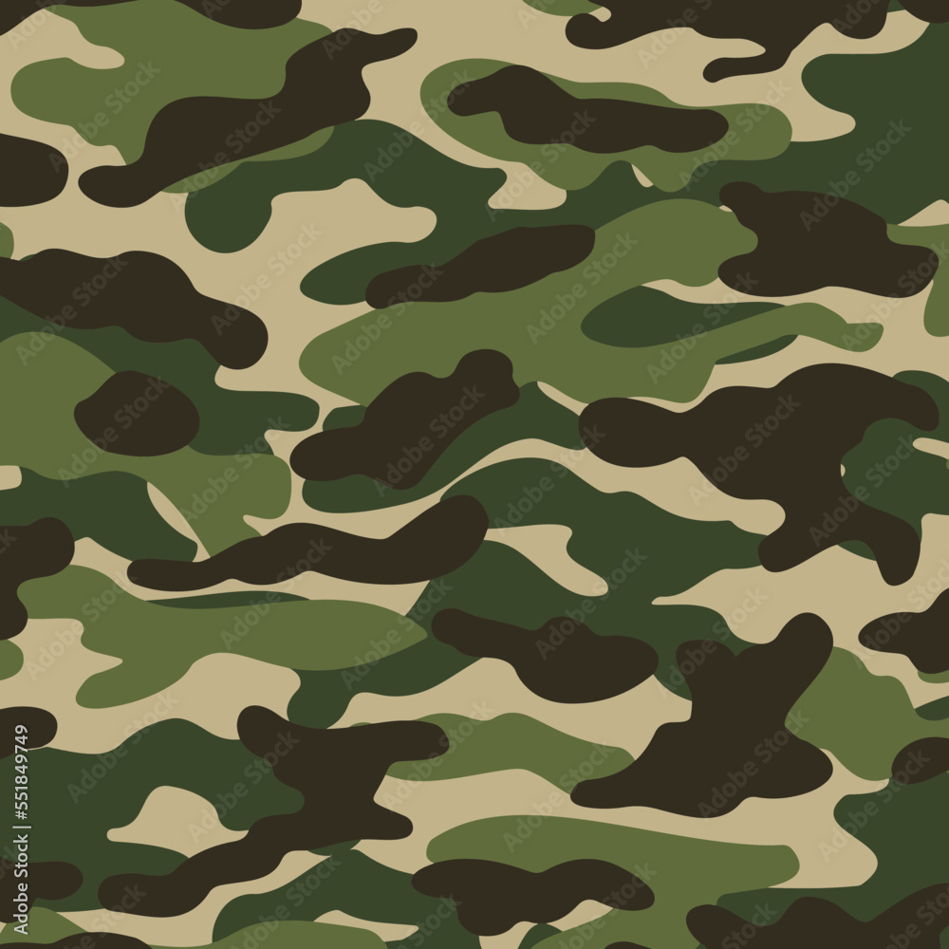 

**Spellings**

Spelling assignments will be set every week on Spelling Shed and will be in their spelling jotter each week along with morning maths activities.

Mathematics

This term we will be learning how to find equivalent fractions, decimals and percentages before developing our skills in finding the area of a triangle and the volume of a given 3D shape.

**HOME CHALLENGE**

Home challenge this half term can be anything on any of the topics we have covered this half term. Using what they’ve learnt as a starting point, we are challenging all the children to create something to share with the whole class on Friday 27th June. Whatever they choose to do, it should add to what they’ve learnt in some way. This could be a poem, a story, a presentation, a dance, a song, in fact, it could be in any format they like!

**Science**

During this unit of work, children will explore how animals and plants adapt to the environment in which they live. They will learn that adaptations occur over time and that may lead to a species evolving. Children will conduct an experiment to answer the question; which beak is best adapted to pick up a seed? They will consider how certain adaptations occur in response to environmental conditions. They will learn about natural selection and how this links to inheritance and how some characteristics are inherited from their parents, and some are not*.*

.

**Foundation Subjects**

**History**

Children will develop a familiarity with the location of the countries involved in the first year of World War II

**Computing**

Children will modify and adjust objects in a 3D space and recognise the difference when working with 3D objects in comparison to 2D shapes.

**Religious Education**

Children will be exploring the festivals that are important to Christians.

**PE**

We will be learning the following skills using a variety of sports  sprintingpace, jumping, throwing, batting stroke, fielding and mountain biking technique & control.

**Music**

Sing and perform songs from WW2. Listen to recorded and live performances and discuss their origin & story. Compose & perform own music.

**French**

Children will learn how to tell the time and discuss their daily routines.

**Support at Home**

Please support your child by encouraging then to complete their Reading Journal regularly and check their jotter for spellings and morning math calculations. You may also assist with learning or revisiting multiplication facts to twelve.

Times Table Rockstars is also available through their Wonde log in. If you would like to email, please use the following address:

[**hello@stbreock.org.uk**](mailto:hello@stbreock.org.uk)

**Summer Term**

Children will explore fiction, non-fiction, and poetry throughout the theme of World War II. They will read and discuss Carrie’s War, explore how the author uses historical details to place the book in time and debate the right and wrongs of Carrie’s actions. They will research the Blitz and evacuations, writing an information poster for children. They will investigate first-hand accounts of evacuation and the European children’s experiences and read parts of The Diary of a Young Girl by Anne Frank and finally plan and write their own wartime stories.

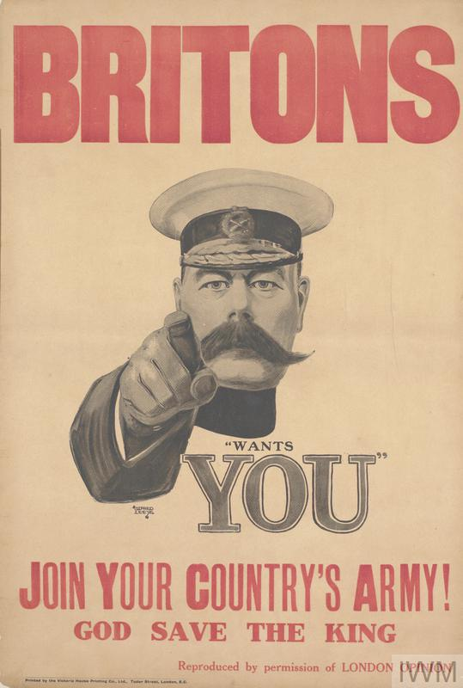

**Year Six**

**Mrs Hawkins**

**Mrs Martell**

**Summer Term 2025**

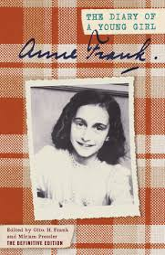

**Literacy**

Children will discuss why Carrie’s War is written as a flashback, with a present-day opener and ending. Children use these discussions to help them answer questions about the role and impact of flashbacks. They will plan a major event for their story and use drama to explore ideas for a major story event. Children will write a detailed ‘day in the life of’ their lighthouse keeper character. Children recall events, memories and achievements from their time at primary school. They will use these to form a plan for their autobiography. Children will write about their hopes, dreams and wishes for their future in their concluding paragraph. They will then edit and improve their autobiography.



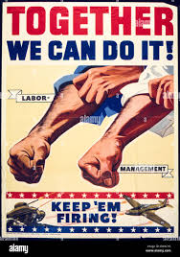

[Grab your reader’s attention with a great quote from the document or use this space to emphasize a key point. To place this text box anywhere on the page, just drag it.]

**Spellings**

*This term we will continue to make our way through the Year 3 statutory spellings and these will be available to revise on Spelling Shed and Google Classroom each week.*

**World War II**

**1939-1945**

Hi